**A Mid-Term Progress Report**

**on**

**ExpensoMeter**

**Submitted in partial fulfillment of the requirements for the award of the degree of**

**Bachelor of Technology**

**In**

Computer Science and Engineering



SUBMITTED BY

Samridhi Sharma Sapna Maurya Shafneet Kaur

URN: 2203551 URN: 2203557 URN: 2203560

UNDER THE GUIDANCE OF

Dr. Inderjit Singh

Batch: 2022-2026

**GURU NANAK DEV ENGINEERING COLLEGE**,

**LUDHIANA - 141006**

### **ABSTRACT**

**ExpensoMeter – Expense Tracking Application Based Project**

In today's fast-paced world, managing personal finances efficiently is essential for achieving financial stability and long-term goals. Many individuals struggle with tracking their expenses, leading to unplanned spending, difficulty in saving, and a lack of financial awareness. **ExpensoMeter** is a **user-friendly expense tracking application** designed to address this challenge by providing an intuitive platform for monitoring, categorizing, and analyzing expenditures.

The application allows users to **record expenses, set budgets, and visualize financial trends** through interactive reports and graphical insights. By leveraging **local storage**, ExpensoMeter ensures seamless data management without dependency on external databases, making it accessible and efficient. The system also aims to integrate **machine learning-based analysis** to identify spending patterns and **AI-powered alerts** to notify users when they exceed their predefined budgets.

ExpensoMeter not only simplifies personal finance management but also promotes financial discipline by offering **detailed expense reports, category-wise breakdowns, and smart financial recommendations**. This project is designed to empower users to take control of their financial well-being, make informed decisions, and cultivate responsible spending habits.

**ACKNOWLEDGMENT**

We extend our sincere gratitude to Dr. Kiran Jyoti, Head of the Computer Science and Engineering Department at GNDEC, Ludhiana, for her continuous guidance, encouragement, and invaluable insights throughout the development of our project, ExpensoMeter. Her unwavering support has been instrumental in shaping this project and ensuring its successful execution.

We are deeply indebted to our project guide, Dr. Inderjit Singh, for his expert supervision, patient mentorship, and constructive feedback at every stage of this work. His technical expertise and dedication played a pivotal role in overcoming challenges and refining the functionality of our application.

We also express our heartfelt appreciation to Prof. Jasdeep Kaur and Prof. Harkomalpreet Kaur, Project Coordinators and all the faculty members of the Computer Science and Engineering Department, GNDEC, for their intellectual support, encouragement, and valuable suggestions. Their insights helped improve the usability and effectiveness of ExpensoMeter.

Furthermore, we would like to express our sincere gratitude to Dr. Sehijpal Singh, the Principal of Guru Nanak Dev Engineering College, for fostering an environment that promotes learning and innovation. His leadership and vision have played a significant role in providing us with opportunities for professional growth.

Lastly, we acknowledge the contributions of our friends, family, and peers who supported us directly or indirectly throughout this journey. Their motivation, cooperation, and belief in our abilities were vital in bringing this project to fruition.

**LIST OF FIGURES**

**Topic Page No.**

Figure 4.1: Level 0 DFD 6

Figure 4.2: Level 1 DFD 6

Figure 5.1: Workflow 9

Figure 5.2: System Architecture 10

Figure 7.1: Home Page 12

Figure 7.2: Login 12

Figure 7.3: Register 12

Figure 7.4.1: Expenses Page 13

Figure 7.4.2: Entries added in Expenses Page 13

Figure 7.4.3: Recent Entries shown on Expenses Page 13

Figure 7.5: Analysis Page 14

**INDEX**

**Topic Page No.**

***Abstract i***

***Acknowledgement ii***

***List of Figures iii***

**CHAPTER 1 INTRODUCTION 1**

**1.1** Brief Introduction 1

**1.2** Objectives of Project 1

**CHAPTER 2 SYSTEM REQUIREMENTS 2-3**

**2.1** Software Requirements 2

**2.2** Hardware Requirements 2-3

**2.3** Technologies Used 3

**CHAPTER 3 SOFTWARE REQUIREMENT ANALYSIS 4-5**

**3.1** Define the Problem 4

**3.2** Define the Modules and Their Functionalities4-5

**CHAPTER 4 SOFTWARE DESIGN 6**

**4.1** Data Flow Diagrams (DFDs)6

**CHAPTER 5** **CODING /CORE MODULE 7-10**

**5.1** Frontend Architecture 7

**5.2** Backend and Data Handling 7-8

**5.3** Workflow and Interaction Model 8-9

**5.4** ML Integration for Financial Analysis 9-10

**5.5** System Architecture Diagram 10

**CHAPTER 6 PERFORMANCE OF THE PROJECT DEVELOPED 11**

**6.1** Established Features (Successfully Implemented)11

**6.2** Features in Progress 11

**CHAPTER 7 OUTPUT SCREENS 12-14**

**7.1** Home Page12

**7.2** Login 12

**7.3** Register 12

**7.4** Expenses Page 13

**7.5** Analysis Page 14

**REFERENCES 15**

**CHAPTER 1 INTRODUCTION**

**1.1** **Brief Introduction**

Rightly said, “Financial health hinges on understanding where your money goes.” In today's fast-paced world, keeping track of expenses can be a daunting task. From daily coffee runs to unexpected bills, our finances often feel like a chaotic puzzle, making personal finance management crucial for achieving financial stability and goals.

By meticulously recording every expenditure, we gain insights into areas of overspending, enabling better financial awareness. Incorporating expense tracking into daily routines helps individuals understand spending habits, make informed decisions, and improve overall financial health.

This project, ExpensoMeter, is a user-friendly application designed to empower individuals to take control of their finances. It makes financial management easily accessible anytime, anywhere. By seamlessly integrating data entry, visualization, and insightful reporting, ExpensoMeter provides users with a powerful tool to monitor their expenses and work toward financial goals.

**1.2 Objectives of Project**

The following objectives will be achieved for this minor project:

1. To create a functional and user-friendly GUI application to track expenses on individual level and at large scale (i.e. for a company).
2. To analyze expenses using Machine Learning and generate detailed reports, identify spending patterns and offer actionable insights for better financial management.
3. To implement AI-powered suggestions and alerts when users exceed their budget.

**CHAPTER 2 SYSTEM REQUIREMENTS**

**2.1** **Software Requirements**

The development process relies on various software tools to streamline coding, version control, and deployment:

* **GitHub**
  + Primary platform for version control, collaboration and deployment.
* **GitHub Desktop**
  + Simplifies repository management.
* **VS Code**
  + Integrated development environment (IDE) for writing and debugging code.
* **Command Prompt (Cmd)**
  + Supports essential command-line operations.
* **Local Storage**

**-** Used for storing user data temporarily before syncing with cloud services.

**2.2** **Hardware Requirements**

For optimal project execution, the following hardware components are essential:

* **Laptop**
  + A reliable system with sufficient processing power and storage to handle development tasks efficiently.
* **Stable Internet Connection**

- Ensures smooth online collaboration, access to resources, and seamless deployment activities.

**2.3 Technologies Used**

* **Frontend Development:**
  + HTML, CSS, JavaScript (for basic structure and styling)
  + React.js (for dynamic and responsive user interfaces)
* **Backend Development:** 
  + Browser Local Storage & Session Storage
  + Used to store user data persistently on the client-side without requiring a backend database.
* **ML Integration:**
  + Python-based analysis report generation for expense tracking using trained data models.

These system requirements collectively provide a strong foundation for the successful execution of the ExpensoMeter project.

**CHAPTER 3 SOFTWARE REQUIREMENT ANALYSIS**

**3.1 Define the Problem**

ExpensoMeter is designed to simplify personal finance management by providing an intuitive platform for recording, categorizing, and analyzing expenses. The system requirements are categorized into data, functional, performance, and security needs to ensure efficiency, reliability, and user-friendliness.

**3.2** **Define the Modules and Their Functionalities**

**3.2.1 Data Requirements**

ExpensoMeter will store and manage user-generated financial data, including transaction details, spending categories, and budget allocations. Since the application relies on **local storage**, all expense records will be securely saved on the user’s device using **Browser Local Storage**. Data privacy will be maintained by encrypting sensitive financial information.

**3.2.2** **Functional Requirements**

* **User Authentication**: Secure login and registration using email or third-party authentication to ensure data privacy and personalization.
* **Expense Management**: Users can add, edit, and delete expenses while categorizing transactions based on date, amount, and payment method.
* **Category Management**: Predefined and customizable spending categories with budget allocation per category.
* **Expense Visualization**: Interactive charts and reports provide monthly and yearly financial summaries.
* **Budgeting & Alerts**: Machine learning-based spending insights, notifications, and alerts when budget limits are exceeded.
* **Offline Data Storage**: Local Storage ensures offline functionality and seamless user experience without requiring an internet connection.

**3.2.3** **Performance Requirements**

* **Lightweight Storage**: Utilizing Local Storage ensures quick read and write operations without dependency on external servers.
* **Responsive Design**: The application will be accessible on both web and mobile platforms with a smooth and intuitive UI.
* **Optimized Load Handling**: Efficient handling of expense tracking and visualization without delays.

**3.2.4 Security Requirements**

* **Data Encryption**: Sensitive financial data stored in Local Storage will be encrypted to prevent unauthorized access.
* **Authentication Mechanisms**: Secure login system with password hashing and session-based authentication.
* **User Privacy**: Since data is stored locally, no financial data is transmitted to external servers, ensuring complete user control.
* **Regular Updates**: Security patches and enhancements will be applied periodically to prevent vulnerabilities.

By meeting these requirements, ExpensoMeter will provide users with a secure, efficient, and intelligent expense tracking system that enhances financial awareness and control.

**CHAPTER 4 SOFTWARE DESIGN**

**4.1 Data Flow Diagrams (DFDs)**

**4.1.1 Level 0 DFD (Context Level)**

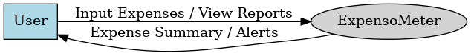

Figure 4.1: Level 0 DFD

**4.1.2 Level 1 DFD**

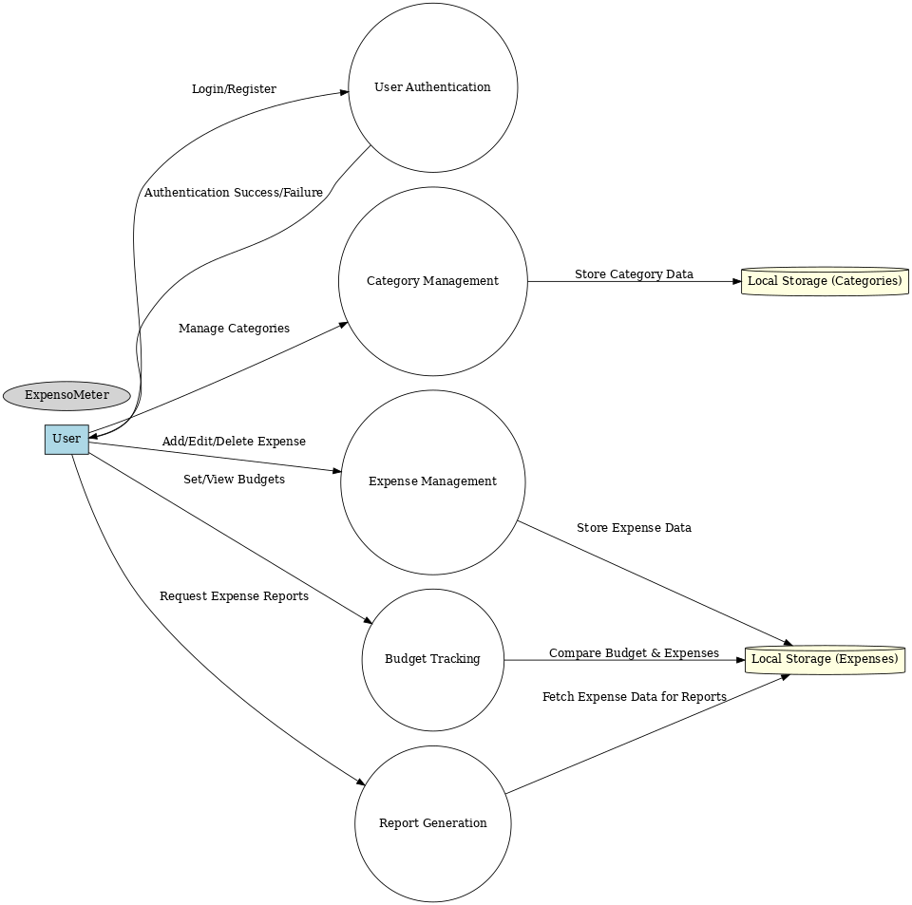

Figure 4.2: Level 1 DFD

**CHAPTER 5 CODING/CORE MODULE**

**5.1** **Frontend Architecture**

The frontend of ExpensoMeter is built using React.js, following a component-based architecture for modularity and maintainability.

**5.1.1 Component Breakdown**

The application consists of multiple UI components:

1. **Navigation Bar –** Provides access to different sections (Home, Expenses, Analysis, etc.).
2. **Home Page –** Displays an overview of features and quick-access links.
3. **Login & Register Pages –** Handles user authentication.
4. **Expense Entry Form –** Allows users to input expenses (date, category, amount, etc.).
5. **Expense List –** Shows all recorded expenses.
6. **Analysis Page –** Displays expense trends through charts and graphs.

**5.1.2 State Management**

* **useState –** Stores dynamic data like entered expenses.
* **useEffect –** Fetches stored data from local storage and updates UI.

**5.2** **Backend and Data Handling**

ExpensoMeter relies on **browser local storage** for data persistency.

**5.2.1 Data Storage Structure**

Expenses are stored in **JSON format** in **localStorage**, where each expense entry contains:

* **id** – Unique identifier for each expense.
* **date** – Date of the expense.
* **category** – Category (Food, Transport, Shopping, etc.).
* **amount** – Expense amount.
* **description** – User-added notes.

**5.2.2 Data Handling Functions**

The application includes various functions to interact with **localStorage**:

1. **Add Expense** – Saves a new expense entry to storage.
2. **Retrieve Expenses** – Fetches all stored expenses for display.
3. **Update Expense** – Modifies an existing entry.
4. **Delete Expense** – Removes an expense record.

**5.3** **Workflow and Interaction Model**

The application follows a structured workflow to ensure smooth operation:

**5.3.1 User Flow**

1. **User opens ExpensoMeter** – Home page loads existing expense data.
2. **User adds an expense** – Data is stored in localStorage.
3. **Expense list updates in real-time** – User can edit or delete records.
4. **Analysis module processes training data** – Displays trends and alerts.
5. **Machine Learning module (upcoming)** – Analyzes spending patterns.

**5.3.2 Interaction Between Components**

The following diagram illustrates the interaction between frontend components and local storage:

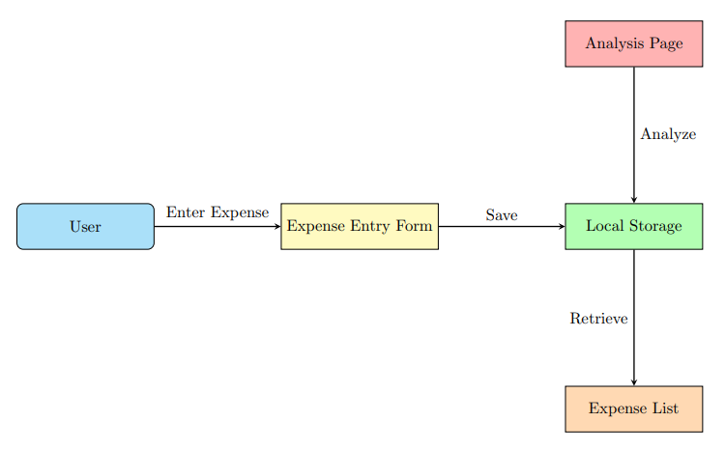

Figure 5.1: Workflow

* **Expense Entry Form** – Stores user input in localStorage.
* **Expense List** – Retrieves and displays saved expenses.
* **Analysis Page** – Reads data and generates spending insights.

**5.4** **ML Integration for Financial Analysis**

The Machine Learning (ML) component in this project is currently focused on **analyzing financial data**. The primary goal is to **visualize category-wise and amount-wise distribution** using **pie charts and bar charts**.

**5.4.1 Training Data Processing**

* **Data Collection -** The dataset is derived from training data.
* **Data Preprocessing -** All transformations and analysis are based on training data.

**5.4.2 Visualization & Insights**

* **Bar Chart:** Displays total spending per category, providing insights into major expense areas.
* **Pie Chart:** Shows the percentage distribution of expenses across different categories.

**5.5** **System Architecture Diagram**

Here’s an overview of how different parts of the system interact:

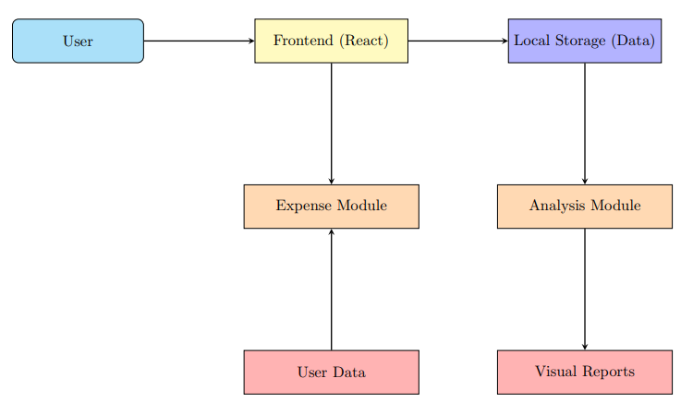

Figure 5.3: System Architecture

**CHAPTER 6 PERFORMANCE OF THE PROJECT DEVELOPED**

The **ExpensoMeter** project is designed to provide a **functional and user-friendly application** for tracking expenses and improving financial management. Its performance can be evaluated based on the following aspects:

**6.1** **Established Features (Successfully Implemented)**

* **Record Expenses** – Users can record their expenses regularly.
* **Categorize Expenses** – Users can categorize and group their expenses with details like date, amount and expense type.
* **Local Storage Integration** – Data is efficiently stored and retrieved using the browser’s local storage.

**6.2** **Features in Progress**

* **Machine Learning-Based Analysis** – Work is underway to analyze spending patterns and generate financial insights.
* **AI-Powered Suggestions & Alerts** – The system will provide recommendations and warnings when users exceed their budget.

**CHAPTER 7 OUTPUT SCREENS**

**7.1 Home Page**

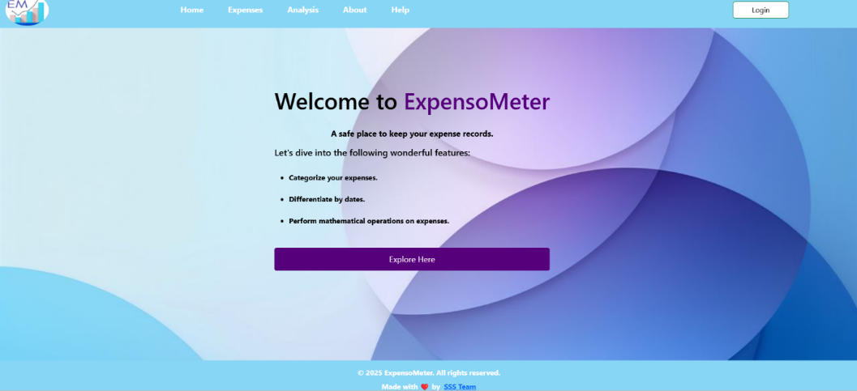

Figure 7.1: Home Page

**7.2 Login**

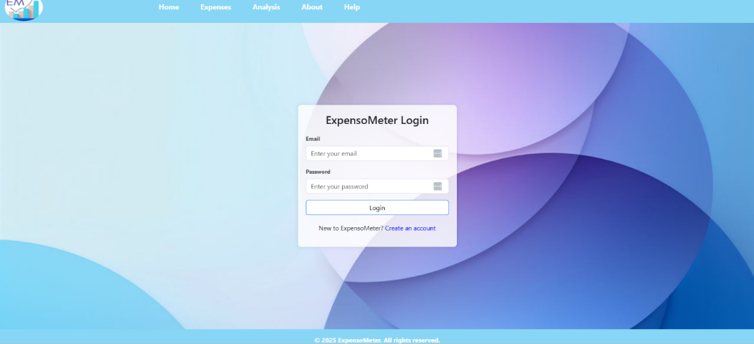

Figure 7.2: Login

**7.3 Register**

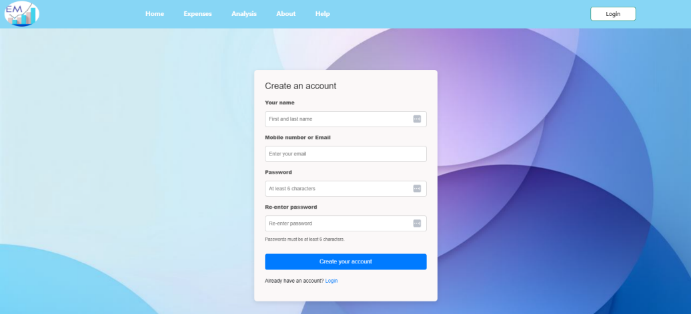

Figure 7.3: Register

**7.4 Expenses Page**

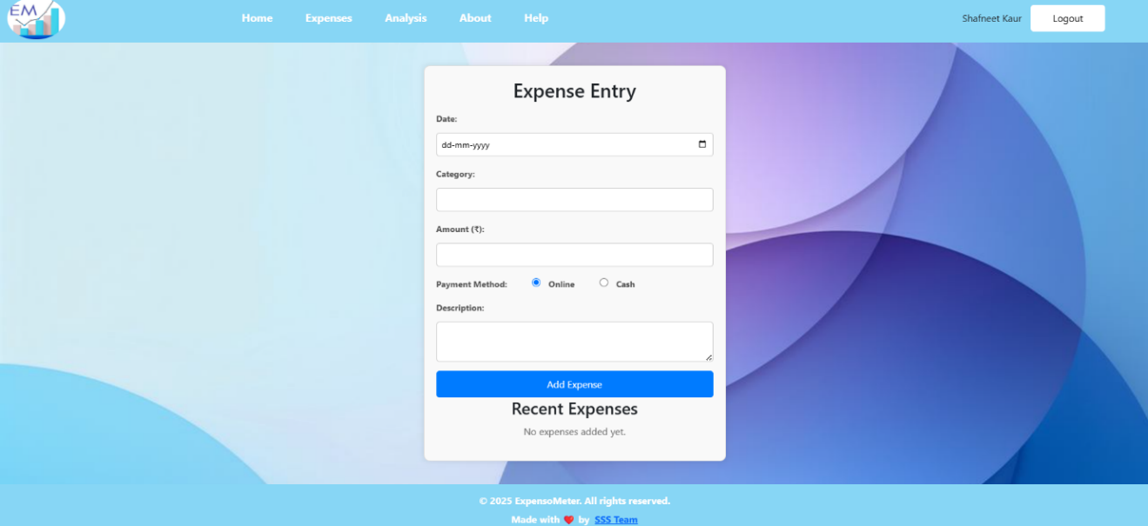

Figure 7.4.1: Expenses Page

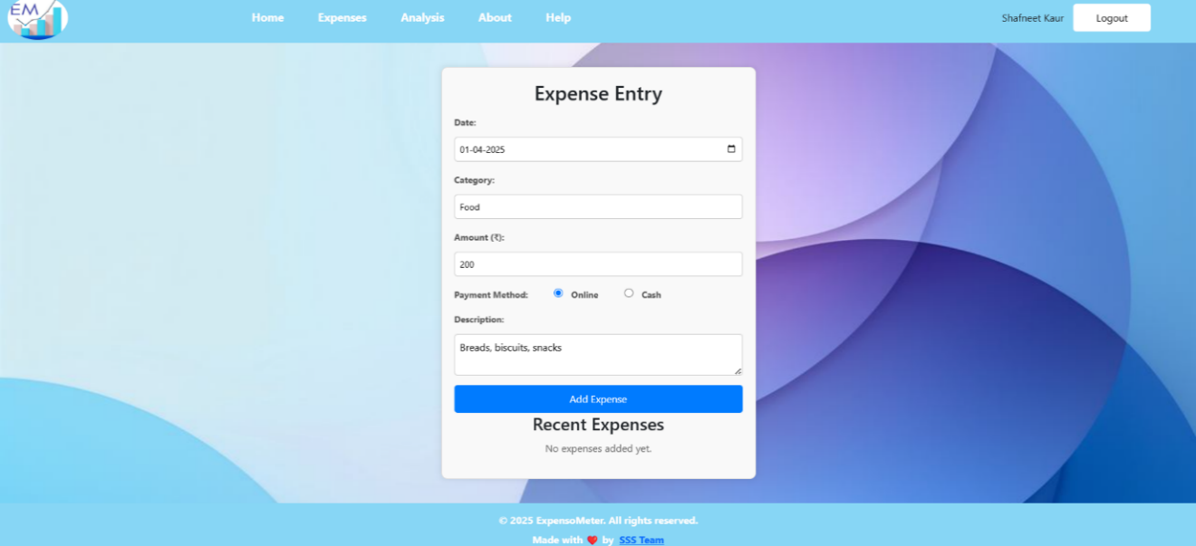

Figure 7.4.2: Entries added in Expenses Page

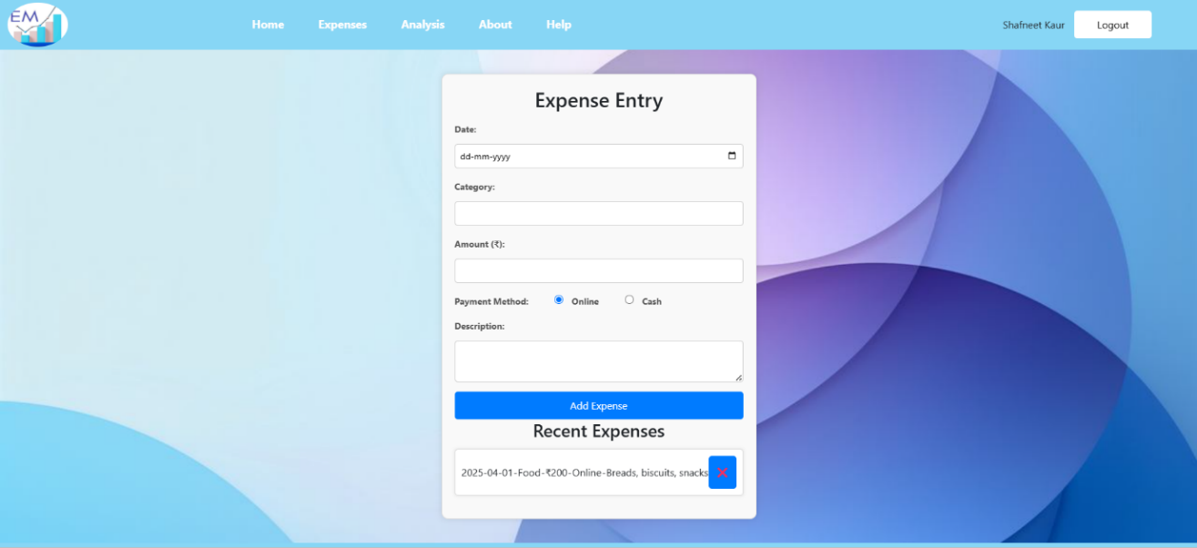

Figure 7.4.3: Recent Entries shown on Expenses Page

**7.5 Analysis Page**

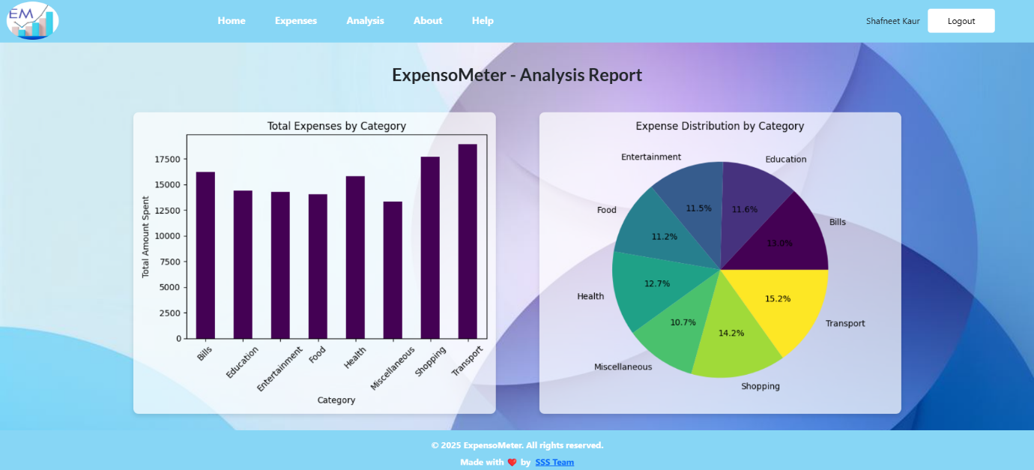

Figure 7.5: Analysis Page

**REFERENCES**

[1] Google, "Google Search," Google. [Online]. Available: <https://www.google.com>. [Accessed: Jan. 21, 2025].

[2] W3Schools, "HTML, CSS, JavaScript Tutorials," W3Schools. [Online]. Available: <https://www.w3schools.com/>. [Accessed: Jan. 21, 2025].

[3] React, "React: A JavaScript library for building user interfaces," React. [Online]. Available: <https://reactjs.org/>. [Accessed: Jan. 21, 2025].

[4] Stack Overflow, "Developer Community," Stack Overflow. [Online]. Available: <https://stackoverflow.com/>. [Accessed: Jan. 21, 2025].

[5] GitHub, "GitHub: Where the world builds software," GitHub. [Online]. Available: <https://github.com/>. [Accessed: Jan. 21, 2025].